Online Enrollment Procedure using Safenet iKey 2032 Token

- Insert the Safenet iKey 2032 Token in the USB port of the computer.
- You can now see the Safenet iKey 2032 properties from the Start Menu by selecting Programs>Safenet>Borderless Security PK>Safenet Token Utilities.



- Initialize the iKey 2032 Token.

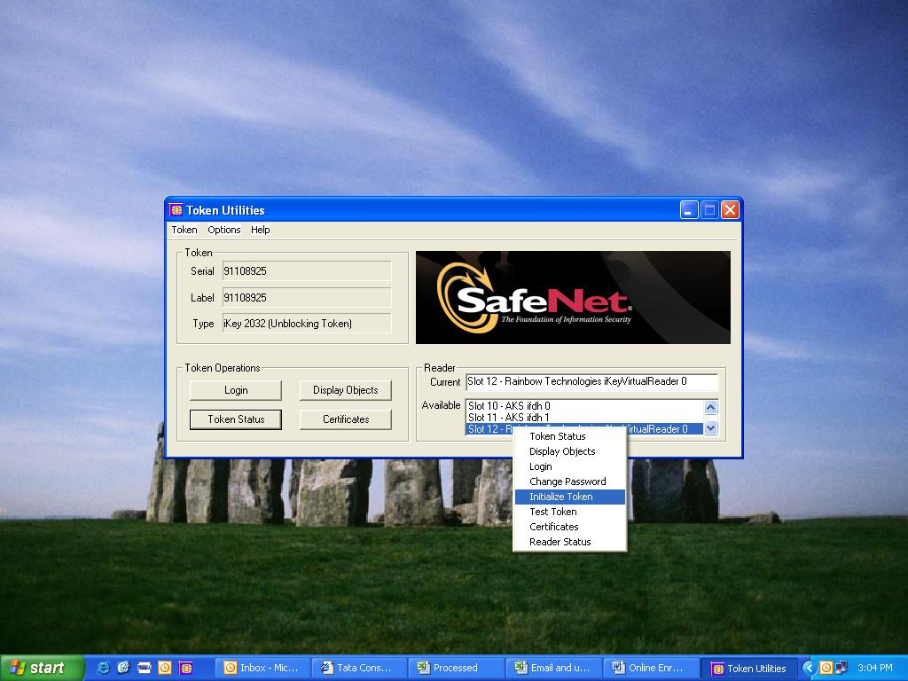
- It gives the warning, Click on Continue Initialization.

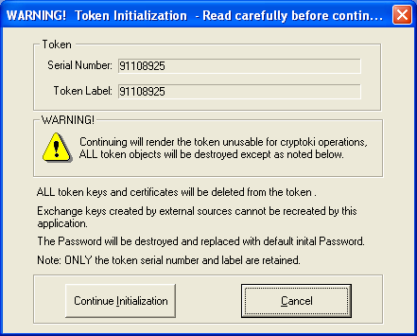

- The New Password is set as shown in Snap shot below.

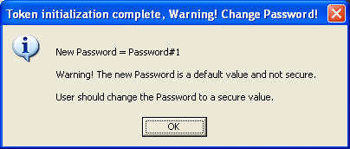

Note: The default password for Safenet iKey2032 is Password#1.

Online Registration

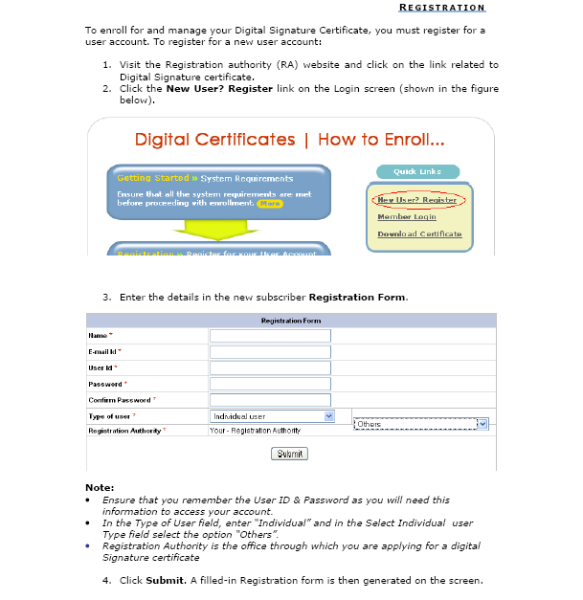

Submit Online Request

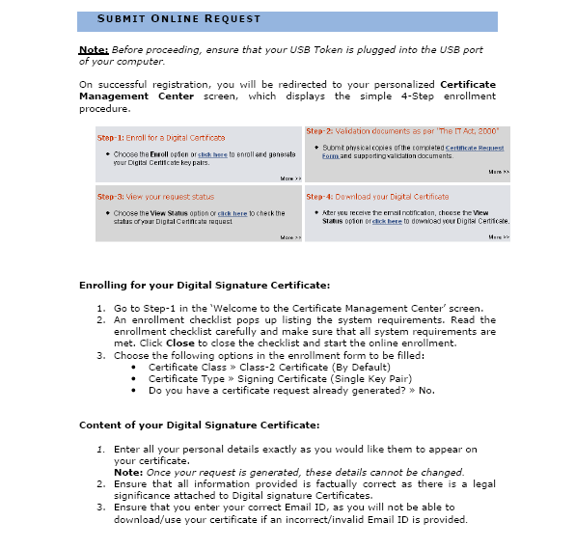

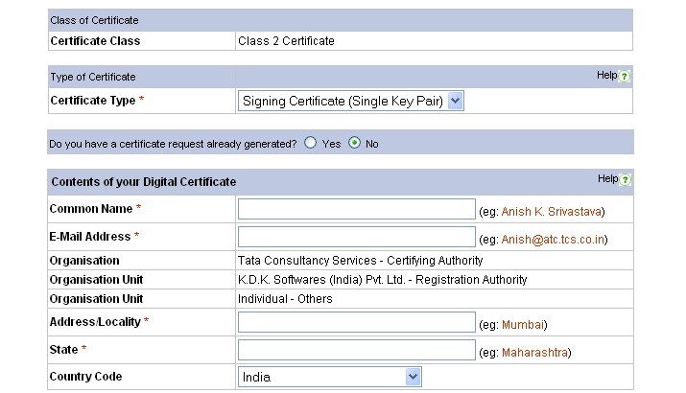

Note: In order to generate the Cryptographic Keys on your iKey2032 Token, Select the Datakey RSA CSP from the dropdown menu on the Enrollment Page and click on Generate Request button as shown.

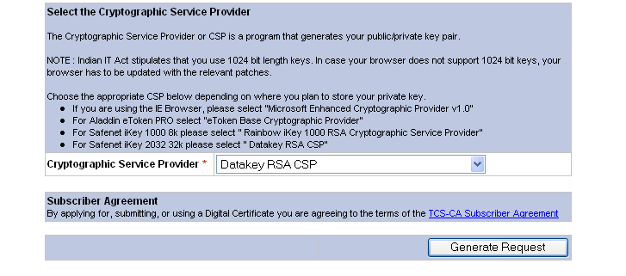

Note: Once your certificate request is generated you can not change any information.
Ensure that all information is correct before you proceed.

The following dialogue box appears. Confirm your details Email Id and CSP selected and click Ok.

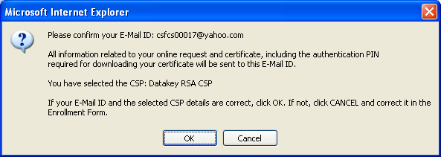

Click Yes to request for a New certificate.

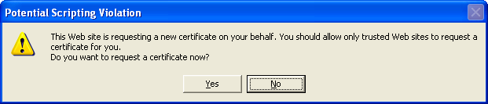

Enter the Password for iKey2032 Token when prompted and click Ok.

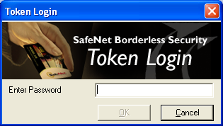

On Successful completion of enrollment, you will see the below screen.
Note the Request Number (highlighted below). Print this form for your records by clicking Print.

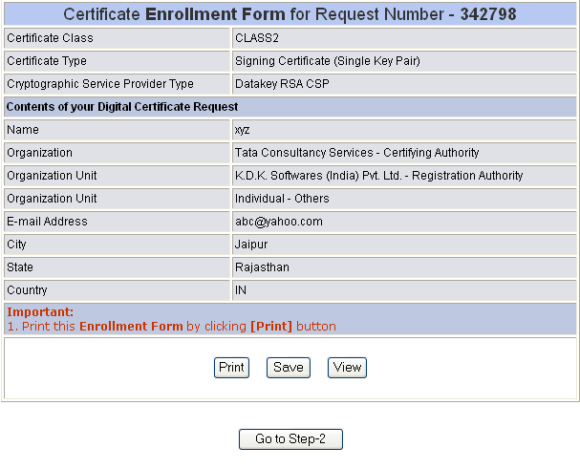

Download your Certificate

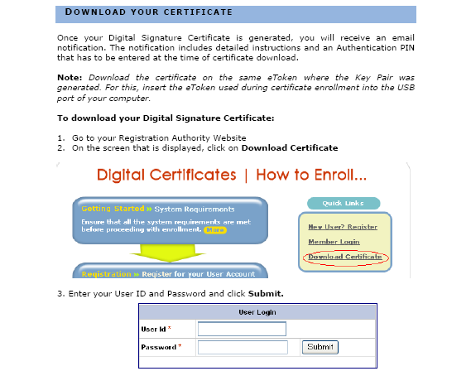

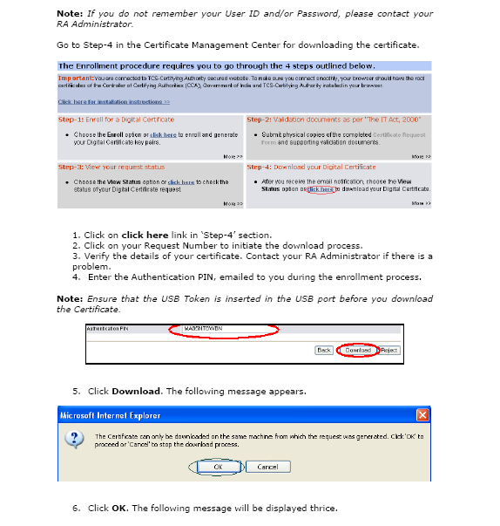

Click OK. The following message will be displayed five times.

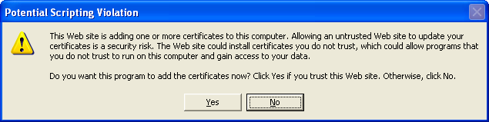

Click Yes. The following dialog asks for Pass-phrase of iKey2032 Token.

Click OK. The following certificates are downloaded:
- CCA Certificate
- TCS-CA Certificate
- End user Certificate.

The following dialog box appears. Click OK.



